**Greenhouse Gas Cost of Beef Restaurant Menu Options**

**INTRODUCTION/BUSINESS PROBLEM**

Anyone who is committed to preserving the planet and/or protecting the health of themselves and their loved ones should be motivated to expand their understanding of the complex network of causes driving the global climate crisis we face. Only recently did I become aware of the environmental impact of my food choices. On its website, the EPA (Environmental Protection Agency) defines GWP (Global Warming Potential) as a measure of gases other than CO2 and how they warm the Earth. The information below provides some facts about the GWP of methane (a gas generated by beef/pork production):

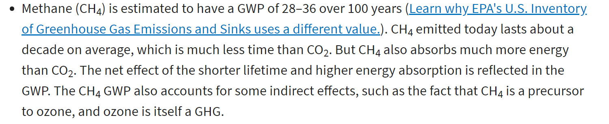

link: <https://www.epa.gov/ghgemissions/understanding-global-warming-potentials>

In this analysis, I will attempt to quantify the Greenhouse Gas Emissions cost of purchasing beef products from a retail food establishment. This should be of importance to a variety of stakeholders, including consumers, regulatory authorities, legislative officials, and businesses that are motivated to improve sustainability practices and reduce their contribution to our global warming crisis. In addition to a review of the statistics relating to beef/pork consumption, my analysis will incorporate Foursquare location data to examine a location’s Greenhouse Gas Emissions Cost associated with beef consumption. Ideally, this would be material information considered as part of the approval process associated with opening new businesses. It should also have an impact on ordinances/regulations governing existing restaurants.

**DATA**

The most popular sandwich at a leading fast food restaurant contains 211g (7.4 oz) of beef. Consumers of this sandwich may not know that they are also purchasing a Greenhouse Gas Emissions unit equal to driving a car almost 9.81 miles (7.40 pounds of CO2-equivalent emissions from producing half a pound of beef – link: [How Meat Contributes to Global Warming - Scientific American](https://www.scientificamerican.com/slideshow/the-greenhouse-hamburger/)). An informative publication by the NRDC tells us that beef “contributes more climate-warming pollution than any other food in the American diet.” (link: <https://www.nrdc.org/sites/default/files/less-beef-less-carbon-ip.pdf>

Data sources for this report include Foursquare and other published datasets (including [Nutrition Facts for McDonald's Menu | Kaggle](https://www.kaggle.com/mcdonalds/nutrition-facts) ). After gathering this data, I plan to utilize the Greenhouse Gas Emissions information cited above (also see EPA’s Greenhouse Gas Equivalencies Calculator (link: <https://www.epa.gov/energy/greenhouse-gas-equivalencies-calculator>) to measure the Greenhouse Gas Cost of each menu. This will be used in conjunction with Foursquare location data to provide a visual representation of the Greenhouse Gas Costs of a location’s retail food establishments.

**METHODOLOGY**

The Foursquare API was utilized to identify restaurants in Quincy, MA and obtain location and other information. Familiarity with the area allowed for verification of FourSquare content.

Quincy is located approximately 9 miles south of Boston and is the largest city in Norfolk County with a population of 92,271 (https://en.wikipedia.org/wiki/Quincy,_Massachusetts).

Using a limit of 100, the API call resulted in 92 venues. The API results yielded 34 unique restaurant categories, shown below:

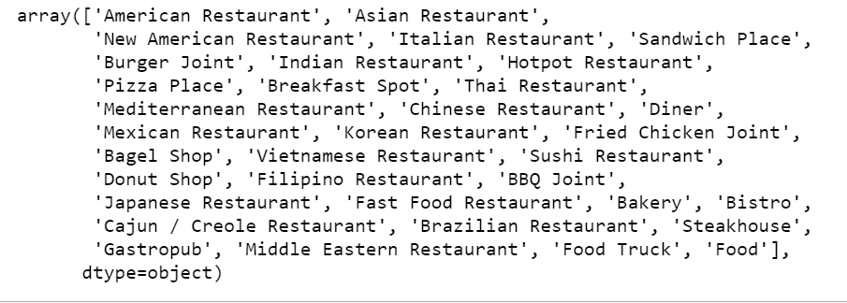

8 venues were eliminated from the population (6 are no longer in operations; 2 have limited menus consisting of baked goods). 2 were added to the population after observation after observing that Starbucks venues do not appear in Foursquare.

Ounces were used for weights since the Scientific American article cited in the Data section of this report refers to ounces of beef consumed.

***NOTES ON DATA CHALLENGES***

Foursquare data could not be relied on entirely for this project. Several of the venues in the list resulting from the initial API call are no longer in operation. Foursquare’s menu url’s were also unreliable sources of information, resulting in the need to use each venue’s website as the starting point for information. Additionally, not all of a location’s venues are listed in Foursquare. Another limitation was drawing a conclusion regarding venue categories (ex. ‘Donut Shop’ category – 1 venue’s menu items are limited to baked goods and was excluded; another venue sells sandwiches and was included in the group). Finally, Foursquare changes occurred during this analysis and resulted in slight changes to dataframe content (and required revisiting to ensure accuracy).

Scraping each venue’s website for the necessary information proved to be a significant undertaking (*information was extracted manually if security measures prevented the importing of url’s from venue websites*). Of the websites reviewed, there did not appear to be a common html format. Theoretically, this would be an opportunity for text recognition. However, there is no standard requirement for restaurant menu content. Recognition barriers included themed menus and categorical confusion (examples: burgers can have various ingredients, i.e. turkey burgers, lamb burgers, or veggie). For these reasons, time constraints prevented the review of each venue in the list of results generated from the API call.

The menu content of 9 locations was analyzed (there are 2 McDonald’s locations in the selected area). Each beef item on the venue’s menu was assigned a weight in ounces (based either on information from the venue’s menu or industry averages). This was used to arrive at each venue’s beef menu total weight. This total was then converted to a Beef Menu Mileage figure (see Scientific American figure cited in the Data section of this report: 8 oz beef consumed = GHG equivalent of driving a car 9.81 miles).

Data sources included:

McDonald’s menu dataset: <https://www.kaggle.com/mcdonalds/nutrition-facts>

Restaurant urls: <https://www.fatcatquincy.com/menu>, <https://www.16crestaurant.com/menu>, <https://idlehourquincy.com/menu/>, <http://www.fiveguys.com/Menu>, <https://shakingcrab.com/quincy>, <https://www.dunkindonuts.com/en/menu>.

**RESULTS**

The good news in terms of GHG metrics is that 4 out of 10 restaurants analyzed had no Beef Menu options. There may be other ways in which these restaurants are negatively impacting climate change, but, this report is limited to the impact of beef consumption.

The remaining 6 restaurants fall into 2 categories: Fast Food/Convenience (3) and Table Service/Moderately Priced (3).

Particular attention should be paid to the Fast Food/Convenience locations. While the weight of each beef menu item at these locations is 3 to 4 ounces, these venues are likely to see a greater volume in beef sales (due to the nature of the Fast Food category and the more affordable menu options). Also of note is the menu composition at one location (beef items make up 75% of the Five Guys beef menu).

The DataFrame below provides the final BeefMenuMileageTotal by venue after analyzing the beef content of each establishment’s menu.

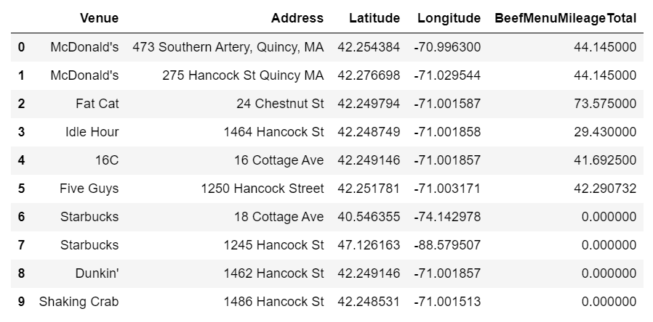

This can be visualized on the map below. Each point represents a venue; the size of the circle corresponds to the venue’s BeefMenuMileage Total.

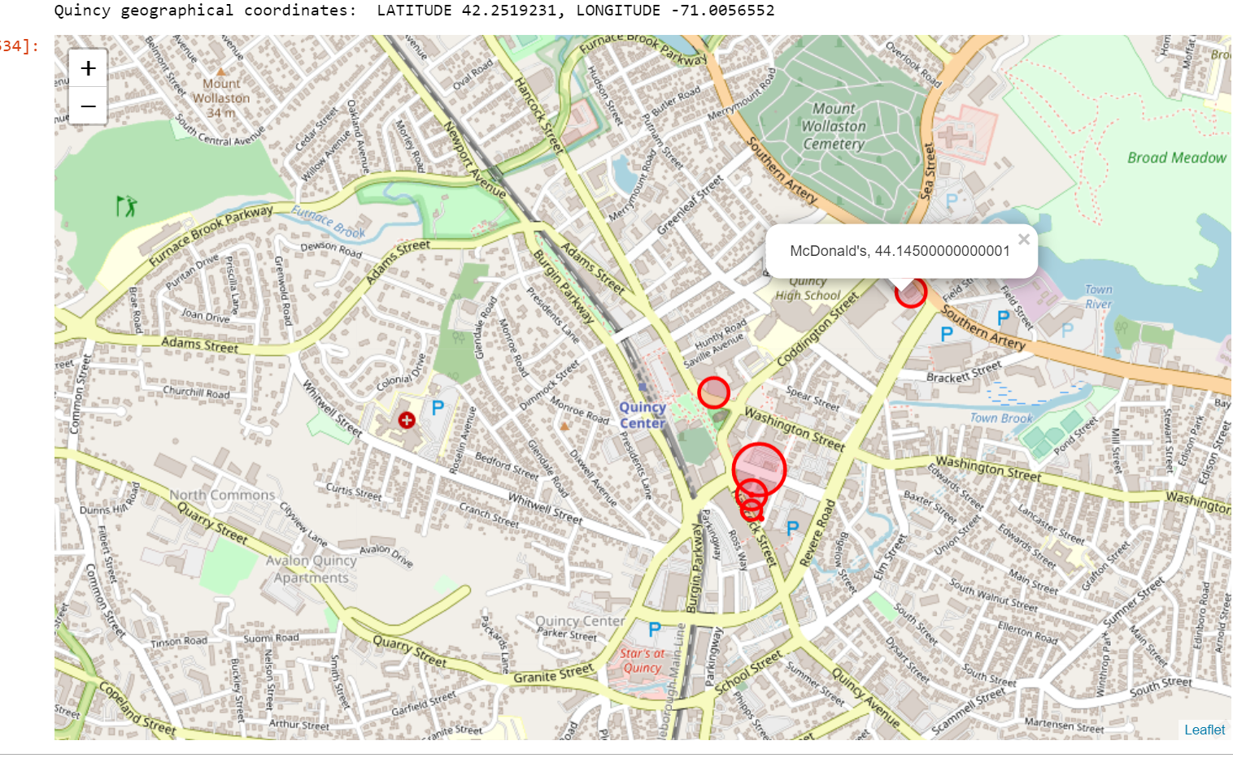

These points are the simplest representation of the impact of each venue’s menu. If each of the 6 restaurants examined sells each beef item on its menu once in a day, it is the Greenhouse Gas emissions equivalent of 1 car being driven for 275 miles (or 14 round trip commutes from Quincy to Boston).

**DISCUSSION**

Further consideration was given to the beef consumption that would result in the Greenhouse Gas emissions equivalent of 1 car on the road for one year (i.e. 11,685 miles driven). This is reached after 410 pounds of beef consumed (410 pounds x 16 = 6,560 ounces).

The dataframe below provides the total # of orders of each venue’s largest Beef menu item to reach this 1 Year GHG equivalent (i.e. reached at McDonald’s after 820 Double Quarter Pounders are sold).

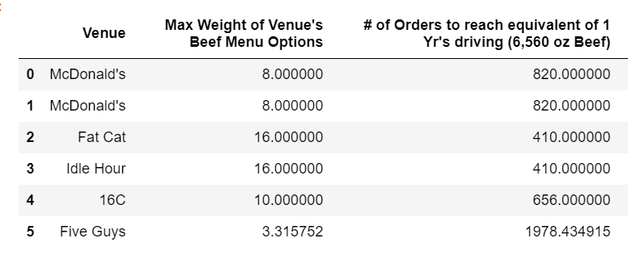

These totals were then analyzed over various time periods to determine the reasonable point after which each venue would reach this equivalent.

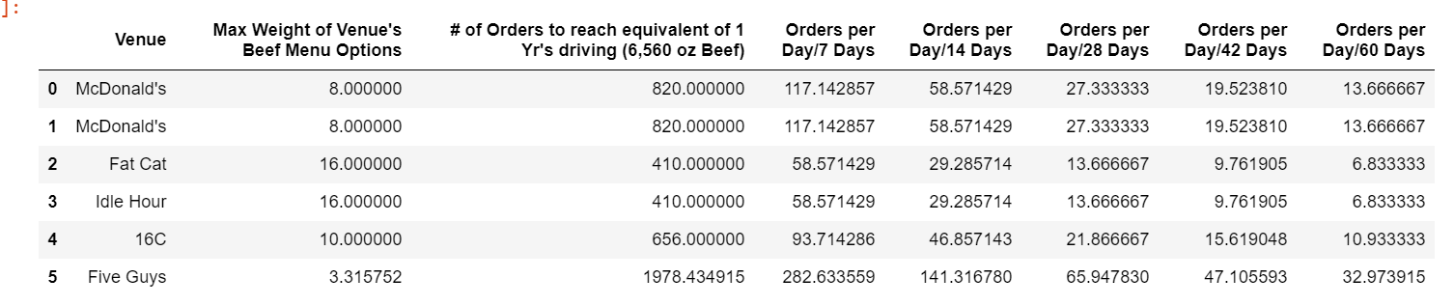

This information is visualized in the bar chart below. Here, we see that a Fast Food venue could conceivably reach the equivalent after one modest week of sales and a full service restaurant would be likely to reach this equivalent after 2 months. In this short time period, 6 venues in one city have the potential to result in the GHG equivalent of 25 cars driven for one year.

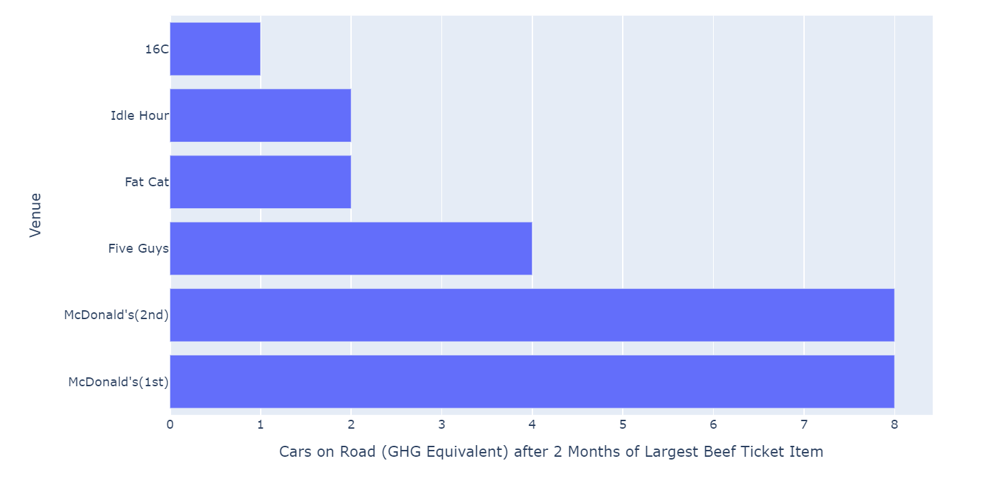

Future analyses should consider giving additional weight to Fast Food restaurants to account for sales frequency. There are numerous practical applications for completing similar analyses on a larger scale, such as calculating the GHG equivalent at institutions (i.e. schools, hospitals, military bases) and large venues (hotels, conventions, stadiums). It also illustrates the challenge of obtaining data in this industry (and identifies a need for standardization and transparency of information).

**CONCLUSION**

The analysis serves to demonstrate the stunning impact of beef consumption at fast food restaurants and other retail venues on our climate. An alternative ending to this story exists with the partnering of Renewable Natural Gas production and the beef and dairy agriculture sector. Of note in this field is AgSTAR, an EPA/USDA-sponsored program that “promotes the use of biogas recovery systems to reduce methane emissions from livestock waste” ( LINK: [What EPA is Doing: AgSTAR | AgSTAR: Biogas Recovery in the Agriculture Sector | US EPA](https://www.epa.gov/agstar/what-epa-doing-agstar)). In the interim, the data serves to assist in clarifying the current state of the industry, makes information available and accessible for delivery in public outreach, education, and legislative measures, and shines a light on areas of opportunity for corporate responsibility.